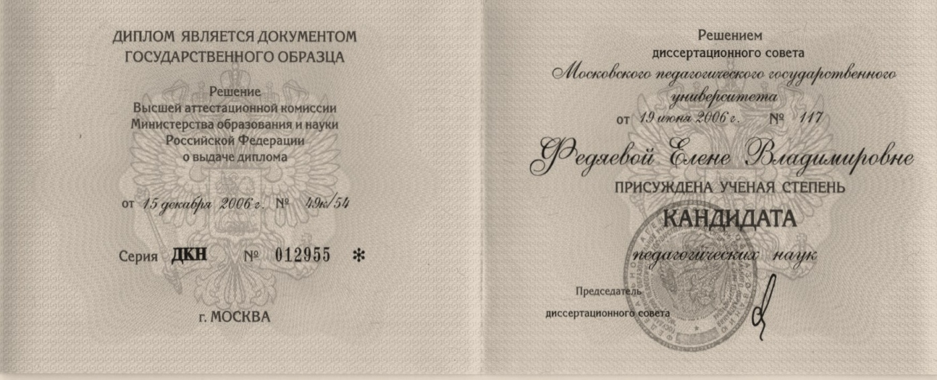
The Russian Federation

Diploma
of Doctor of Philosophy (Ph.D)

This Diploma is a state official document

Decision of the State Commission for Academic Degrees and Titles
of Ministry of Education and Science of the Russian Federation

of issuing this Diploma

d/d December 15, 2006 No. 49k/54

Series ДКН No. 012955 *

The city of Moscow

The Dissertation Council of
Moscow State Pedagogical University
by its decision No. 117on June19, 2006
has awarded to
Elena Vladimirovna FEDYAEVA
a scientific degree of
Doctor of Philosophy (Ph.D)
in Pedagogic Sciences

Head of the Dissertation Council /signed/

Official seal:
Federal Agency for Education * State educational institution of higher vocational education * Moscow State Pedagogical University * Primary State
Registration Number 1027700216344 * Taxpayer Identification Number 7704077771

